# Final Project Report

**Predicting The Price of a House Using Data Mining Methods**

Group No: 12

**Sai Swaroop Tunuguntla (811300334)**

**Yamini Venkata Samskruthi Lella (811305179)**

**Khyathi Swaroop Pathangay (811355978)**

**Abstract:**

Budgets and marketing tactics are typically more cautious for those wishing to purchase a new home. The current approach calculates home values without making the required forecasts regarding future price increases and market trends. The purpose of this project was to use SQL 2008 and Microsoft ASP.NET to create a real estate web application.Buyers can search for homes by address or characteristics thanks to the real estate system's capabilities. It gives the seller capability, allowing them to log in and add new ads or remove ones that already exist. Each user is given a login account with a password and login ID for this purpose.

Prediction is the process of forecasting the unknown, whether it be the past, present, or future, by gleaning from the raw data relevant, intelligible information. Predictive analytics, then, is a subfield of data mining that forecasts or predicts a trend or behaviour. Numerous industries, including credit scoring, weather forecasting, healthcare, transport, and the financial industry, rely on prediction. The purpose of this survey is to provide an explanation of how predictive analytics is used in the real estate industry. The survey's objective is to present the different forecasting methods for real estate values. Various studies conducted in the real estate field are mentioned in the survey. Additionally, it goes into great detail about how decision trees, random forests, XGBoost, and neural networks are utilised to forecast sale prices.

**Keywords**: House prices; real estate price; classification algorithm; price prediction; data mining; market trends

**1. Introduction:**

This project focuses on enhancing the use of prediction markets for economic forecasting, specifically in predicting efficient house pricing based on customer budgets and priorities. By analyzing past market trends and price ranges, the project aims to accurately forecast future property prices.

Real estate is a popular investment choice worldwide, symbolizing wealth and status. As property prices generally rise, potential fluctuations—either declines or stagnation—are influenced by various factors. The economy and the property's geographical location are primary drivers of these price changes. For instance, India's real estate market slowed between 2016 and 2017 due to Demonetization and the introduction of RERA and GST. While the market is stabilizing now, these economic shifts impact investors, policymakers, and banks. Computers, equipped with powerful computing capabilities, can analyze this data faster and more accurately than humans, allowing for the identification of complex patterns—though the data's structure must be clearly defined.

Property prices are influenced by two main types of factors: general (macro-social) and particular (specific). General factors—like the economic condition, political changes, and community demographics—affect broader market trends but not individual property prices directly. In contrast, particular factors—such as house size, location, construction style, available amenities, environment, proximity to urban centers, transport options, and the house's orientation—have a direct impact on pricing. Understanding and considering all these factors is essential for accurate property price predictions.

# **2. AIM AND OBJECTIVE:**

The goal is to accurately predict house prices for real estate customers based on their budgets and preferences. By analyzing market trends and future developments, we can forecast property prices. Our website will allow customers to input their specifications and use a Naive Bayes algorithm to generate insights, enabling them to invest in real estate without the need for an agent, thus reducing transaction risks.

Currently, buying or selling property is complicated and costly, requiring customers to visit multiple locations and pay agent commissions. Additionally, buyers often lack insight into future property value. To address these issues, we are developing a web-based platform that incorporates data mining techniques.

**3. Time-aware Latent Hierarchical:**

It is widely acknowledged that the value of a home is determined by a variety of factors. In practice, house price prediction thus presents a unique set of challenges.[4] While a large body of work is dedicated to this task, their performance and applications have been limited by a lack of long-time-span transaction data, the absence of real-world settings, and a lack of housing features.[4] To that end, a time-aware latent hierarchical model is introduced to capture the underlying spatiotemporal interactions driving house price evolution. When temporal effects are taken into account, the hierarchical perspective eliminates the need for historical transaction data of identical houses. The proposed framework is tested on a large-scale dataset of Beijing property transactions. Essentially, the problem of house price prediction.

on seeks to estimate the future market value of houses based on previous transaction records (but not necessarily the same houses). This issue, however, is fraught with difficulties. To begin, each home has a unique set of characteristics such as location, square footage, number of rooms, and many other specifics.[4] It has traditionally been difficult to collect all housing characteristics on a large scale. .[4] Second, quantifying some external location-related characteristics is more difficult than quantifying internal physical attributes. .[4] For example, there are no unified metrics to measure the overall quality of the environment and education resources, which are critical for the evolution of property value. .[4] Furthermore, these external features are usually dynamic rather than constant.[4].

We propose a time-dependent latent hierarchical model of housing prices to capture how the latent external component forms and evolves. Despite the fact that the value of the external component is not measurable, it is the underlying constraint mechanism that drives observed house prices. To be more specific, the latent value of neighborhoods (external component) varies smoothly and gradually from one time period to the next. The spatial and temporal smoothness constraint aids in the inference of the external component's latent value. In light of the scarcity of transaction records for the same houses over a short period of time [1], [2], we group different houses into the same neighborhood using a predetermined criterion.[4]

# **4. PROPOSED SYSTEM**

Nowadays, e-education and e-learning is highly influenced. Everything is shifting from manual to automated systems. The objective of this project is to predict the house prices so as to minimize the problems faced by the customer. The present method is that the customer approaches a real estate agent to manage his/her investments and suggest suitable estates for his investments. But this method is risky as the agent might predict wrong estates and thus leading to loss of the customers’ investments. The manual method which is currently used in the market is out dated and has high risk. So as to overcome this fault, there is a need for an updated and automated system. Data mining algorithms can be used to help investors to invest in an appropriate estate according to their mentioned requirements. Also the new system will be cost and time efficient. This will have simple operations. The proposed system works on classification algorithm nave Bayes.

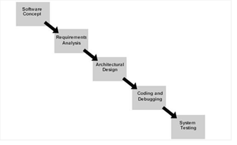

**5.correlation analysis:**

The real estate industry has been critical to China's national economy. As a result, while real estate policy is constantly changing, its long-term pillar industry status will remain unchanged. Real estate, whether used as a commodity or an investment product, has a high market demand in terms of developing industries and future development trends. Understanding the relevant government policies is the key to converting potential demand into actual growth. The development direction, which results in new ideas and new development momentum [1]-[4].

The price of real estate is an important component of the overall price system. From the standpoint of the production field, real estate is the space and location for the production of all commodities. To obtain value compensation, the prices (including rents) paid for this real estate must be included in the production cost and become a component of commodity prices. Housing consumption is an important component of labor reproduction costs from the standpoint of the consumption field. Any commodity's production is inextricably linked to the labor factor. The cost of labor production and reproduction determines labor price [5–7].

**6. Predicting property price**

Property price appraisal is traditionally performed by professional appraisers, which may introduce bias into the valuation process. Unbiased property price predictions are essential, especially for first-time property buyers and those with limited experience in the real estate market. Property prices are affected by two main types of factors: general factors and particular factors. General factors include macro-social factors like the overall economic conditions, political changes, and social demographics, which indirectly influence property prices. Factors, on the other hand, directly impact house prices and encompass aspects such as property size, location, construction style, available amenities, environmental factors, proximity to urban areas, transportation options, and the orientation of the house.

For instance, study compared Artificial Neural Networks (ANN) and Autoregressive Integrated Moving Average (ARIMA) models using data from Singapore's condominium prices. The research found that ANN outperformed ARIMA in terms of accuracy. Another study compared hedonic price models and ANN for predicting house prices in Christchurch, New Zealand. In this case, ANN also outperformed the traditional hedonic model. Additionally, ANN has been employed in the field of stock market predictions, demonstrating an average accuracy rate of 69.72%.

Furthermore, the paper explores ozone prediction using a hybrid approach, combining Principal Component Analysis (PCA) and Neural Networks, achieving promising results. The author's study delves into the influence of macroeconomic parameters on house price variations, using backpropagation neural networks (BPN) and radial basis function neural networks (RBF).

Feature selection and extraction techniques are also discussed, emphasizing their role in dimensionality reduction. Studys application of classifiers like C4.5, RIPPER, Naive Bayesian, and AdaBoost for property price prediction, comparing their performance in determining whether closing prices are higher or lower than listing prices.

Data mining is the process of extracting potentially useful information and knowledge from a large amount of incomplete, fuzzy, and random data. Business perspective definition Data mining emerges as a new information processing technology in the business world. Its primary goal is to extract, transform, analyze, and process data in a database in order to determine what is important for business decision-making. In other words, data mining is a method of analyzing data. Data analysis was previously only used in scientific research. Furthermore, because computers had limited capabilities in the past, the ability to analyze large amounts of complex data was severely limited [2]-[4].

p=[p(1),p(2),…,p(n)]

pTH(+∞)=pIH(1)(2)

Data and knowledge are two entirely distinct concepts. The technology for mining hidden knowledge information from databases has advanced rapidly in recent years. The broad market and research interests have aided in the rapid development of this field. People can collect and store information from a greater distance or at a faster rate using computer technology and data collection technology. These technologies were previously unimaginable. Data collection can yield unexpected results, but data does not represent information. Although modern database technology allows us to easily store large amounts of data streams, it is not yet a mature technology that can help us analyze and understand data. Currently, in the face of a massive data warehouse and traditional.

# **7. ANALYSIS**

FEASIBILITY STUDY: - The very first phase in any system developing life cycle is preliminary investigation. The feasibility study is a major part of this phase. A measure of how beneficial or practical the development of any information system would be to the organization is the feasibility study.

Using the Kaggle dataset, we used 33% for testing and 66% for training.

Data Analysis:

Data type: float64=3, int64= 35, object = 43.

Missing Values:

* examined each feature's percentage of null values.
* Determine the connection between the sas price and missing values.
* Plot a variable graph with a value of 1 for missing observations and 0 otherwise.
* Determine how the dependent variable and the missing values are related.

Temporal Variables (Datetime Variables):

* We have four-year variables there.
* We must retrieve data from the DateTime variables, such as the number of days or years.
* Determine the connection between the sale price and the year the residence is sold.

**8. Random Forest:**

It is extremely difficult for engineers to forecast and analyze the price of a house. It is possible to predict the price of a house using various algorithms and train the dataset on these algorithms using machine learning algorithms [4]. There are so many software and models developed and rolling out in the market these days to more accurately predict the price of a house, with a minor error in predicting that will be ignored. All of the predictions can only be made by analyzing various parts of the house such as the kitchen, bedroom, balcony area, and land area. Many analysts discover the data and compute the same data of the house using various techniques to predict a similar price.

**8.1 Factors that influence House forecast:**

Several factors will influence the price of the house. The main factors influencing the price fall into three categories, but the most important are locality, area, and resources. The main conditions for predicting house prices [5] are the size of the area, the number of rooms in the house, and the availability of all resources in the neighborhood. One can also predict that the environment will be environmentally friendly, with no risk of pollution or disease.

Random forest will also be used because it is an important component of the decision tree for data ensemble. There are many parts in the random forest that can be chosen by the customer based on their requirements. It will be a good machine learning algorithm for training small data sets and predicting good results with greater accuracy.

SVM is a binary classification supervised machine learning model. The linear classifier with the largest interval in the feature space is defined as its basic model [1]. The maximum interval varies depending on whether the perceptron is single or multi-layer. SVM can be transformed into a nonlinear classifier by modeling it with kernel functions [2]. SVMs build two optimal parallel hyperplanes to solve a convex quadratic programming problem, which is equivalent to minimizing a regularized hinge loss function [3]. Their approach to learning is now the most effective solution for convex quadratic programming problems.

The SVM algorithm can solve the separation hyperplane with the largest geometric interval and proper training data set partitioning [3]. Boosting is one of the most significant advances in classification methodology in the last few decades [1]. Boosting is a type of serial learning that is used to train a base classifier. The base classifiers are interdependent. Using special strategies, the boosting algorithm trains several weak classifiers to produce a final strong classifier. Weak classifiers are distinguished by low variance and high bias. The reason for this is that in the sequential process, each subsequent model attempts to correct the errors of the previous one for stagewise fitting. It is not necessary for every strong classifier to have a very low bias. Boosting techniques used in this study included adaptive boosting (AdaBoost), boosting trees, and gradient-boosting decision trees (GBDT).

Because a typical data analytics project involves a series of complicated tasks, there are concerns about the difficulty of using machine learning methods by non-experts. To address the issue, an automated machine learning pipeline that can automate the processes of model selection, hyper-parameter tuning, and feature engineering has been introduced.

**9. User activity:-** User can Search property, add property for selling and can also look for rent by search method after logging in. Results are fetched and added from the main database.

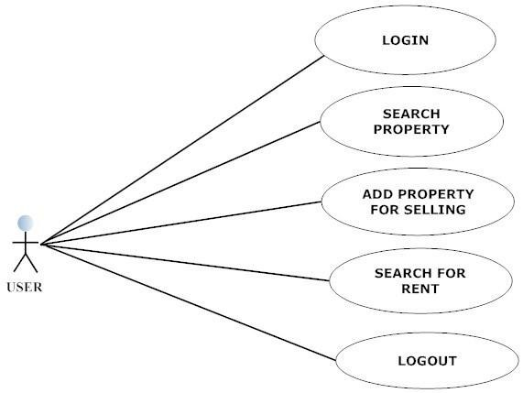

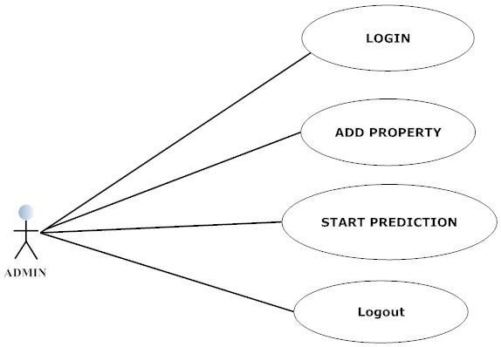

**10. Sequence**:

Admin can log in in his account anytime by putting his credentials. If credentials match in database’s data, system will grant log in. Vice versa is true for user as well. Admin and user both use some kind of web application to connect with database. Admin and user can both search for property and generate prediction codes from database. User can manage his purchase and selling information of system. For logging out, they both have to request a log out request to system. System grants the log out session and they can log out.

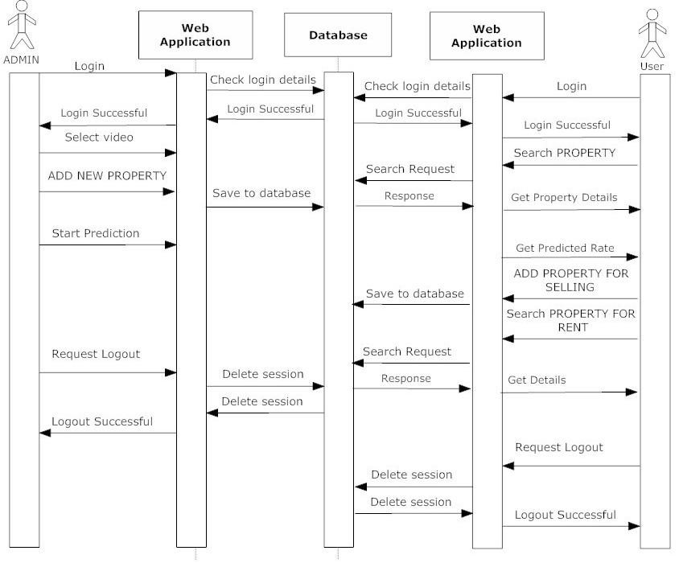

Sequence of action

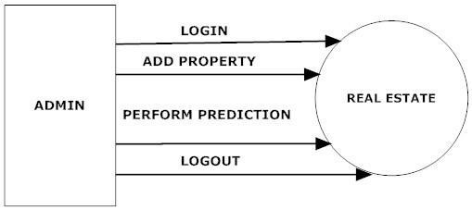

DFD level 0(admin)

DFD admin level1: - Admin have to first log in into the website. When he enters new property then that info will be stored into the database so that it will be easy to retrieve. when the predictions are made, that data also stored into the database.

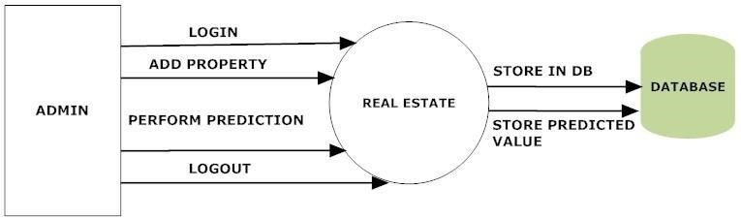

DFD level 1(admin)

**11. Graph Of data analysis**

**12. IMPLEMENTATION PLAN**

In today's world, e-education and e-learning are significantly influencing various sectors. There is a notable shift from manual to automated systems. The objective of this project is to predict house prices to help minimize the challenges faced by customers in the real estate market.

To address these issues, there is a need for an updated and automated system. Data mining algorithms can assist investors in selecting appropriate properties based on their specified requirements. Additionally, the new system will be both cost-effective and time-efficient, featuring simple operations.

The proposed system will utilize a classification algorithm known as Naïve Bayes. The administrator will input property details into the system. Based on this information, the system will predict estimated prices for the properties. When users search for a property, they will see a list of available options along with the predicted prices. Users can also sell their properties by submitting their details to the system and can explore rental options for homes through our proposed platform.

* Managing Categorical Features with Missing Values
* Change the categorical null value to missing.
* Managing Numerical Features with Missing Values
* Since there are outliers, substitute the median value.

**13. House Price Prediction Using Machine Learning**

The research paper aims to provide a solution to this problem by leveraging machine learning techniques. The primary goal is to predict house prices by understanding customer needs and their financial capacity. When a potential buyer looks for a house in a city, several key factors influence their choice, including location, the property's area, and the resources available in the vicinity. By analyzing these factors, the research paper seeks to empower clients with accurate house price predictions, ultimately aiding builders in setting competitive selling prices.

To predict house prices accurately, the authors employed various machine learning algorithms, including Decision Tree, Support Vector Machine, K-Nearest Neighbors (KNN), Random Forest, and Linear Regression. Among these, Decision Tree Regression emerged as the most effective method, with a focus on feature engineering and the analysis of various parts of the house, such as the kitchen, bedroom, balcony area, and land area.

* Data Standardization: The process of transforming data into a standardised format so that users may process and analyse it is known as data standardisation.
* To assign values, use the Minmax scaler.
* Change the data by adding the sales price and ID.

In terms of implementation, the authors emphasized the importance of data preprocessing, which involved handling missing values and splitting the dataset into training and testing sets. The analysis of data, such as calculating the standard deviation, mean, and min-max values, was integral to the preprocessing phase.

A neural network is an artificial intelligence model that was originally designed to mimic the learning process of the human brain. The model is composed of three major layers: the input data layer (for example, property attributes), hidden layer(s) (also known as the "black box"), and output layer [18]. Figure 2 shows a neural network, which is an interconnected network of artificial neurons with a rule that adjusts the strength or weight of the connections between the units in response to externally supplied data. Each artificial neuron (or computational unit) has a set of input connections that receive signals from other computational units, as well as a bias adjustment and a set of input connection weights.

**14. Gradient Boosting:**

The author [15] discussed techniques such as Elastic-Net regression (ENR), Kernel-Ridge regression (KNN), Gradient Boosting and Xgboost to estimate the price of the house in Ames, is a city of lowa, the United States. XGBoost is a popular and efficient open-source implementation of the gradient boosted trees algorithm. Gradient boosting is a supervised learning algorithm, which attempts to accurately predict a target variable by combining the estimates of a set of simpler, weaker models. To evaluate the model, the root mean squared logarithmic error (RMSL) was used.

The author [16] used XGBBoost algorithm for House price prediction. This algorithm provides flexibility, speed, and performance. This study prefers XGBoost to get better accuracy results and lower MAE. The model is trained using XGBRegressor and is validated using validation dataset. The author [2] can achieve 98% accuracy while predicting the house prices in Karachi City, Pakistan. The below table will show the accuracy of the model.

The author [5] had used XGBoost algorithm to predict the house prices. The most crucial reason why XGBoost succeeds is its scalability in all scenarios. The system runs more than ten times faster than existing popular solutions on a single machine and scales to billions of examples in distributed or memory-limited settings. The scalability of XGBoost is due to several major systems and algorithmic optimizations including a novel tree learning algorithm for handling sparse data and a theoretically justified weighted quantile sketch procedure enabling instance weight handling in approximate tree learning. Parallel and distributed computing make learning faster, which allows quicker model exploration. More importantly, the model exploits out-of-core computation and enables data scientists to process a hundred million examples on a desktop. Finally, after combining these techniques to make an end-to-end system, it can scale to even more extensive data with the least amount of cluster resources [12]. In this paper, we utilized the XGBRegressor from xgboost open-source package [13]. After tweaking the XGBoost model multiple times, we set our parameter to the following:

**15. Graph Of Data Analysis:** The passage discusses the application of various machine learning techniques in predicting house prices in the context of the flourishing Chinese real estate market. It highlights the importance of studying and predicting house price changes, especially considering the myriad factors that influence these changes. The passage primarily focuses on three machine learning models: AdaBoost, Linear Regression, and K-Nearest Neighbors (KNN).

AdaBoost, an ensemble learning method, is presented as a powerful tool that performs well when datasets are balanced. It combines multiple weak classifiers to create a stronger one. However, its performance may degrade when faced with highly diverse data. Standardization and feature scaling are used to improve accuracy, while a simple and easy-to-understand method, is more suitable for classification tasks rather than regression. It ranks lower than AdaBoost and Linear Regression in terms of predictive accuracy for house prices. Standardizing data can enhance KNN's accuracy.

**16. Results for regression Models**

In this study, the authors explored the use of machine learning algorithms for forecasting house prices. They noted that house prices fluctuate due to various factors, including location, area, facilities, and more. They assessed their performance using the root mean squared error (RMSE) and found that GBDT and XGBoost.

Linear Regression:

* R2=0.885
* ΜΑΕ 0.029835336354257145
* MSE 0.0019892446825492444
* RMSE 0.04460094934582945
* RMSE Logarithmic -3.1100001344017283

Ridge Regression:

* Ridge Regression Model Training Score: 0.91186
* ΜΑΕ 0.03041
* MSE 0.00184
* RMSE 0.0429
* RMSE Logarithmic -3.148
* r2=0.894348

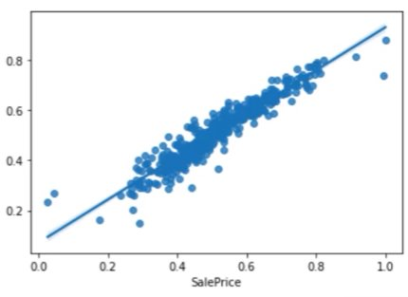

The authors used a dataset with 80 features and 1 label, involving various aspects of houses. They preprocessed the data, including handling missing values and removing outliers. The data was then transformed using one-hot encoding. Bayesian optimization was applied to fine-tune the parameters of the machine learning models.

KNN Method:

* ΜΑΕ 0.10386159509314839
* MSE 0.017648151921868617
* RMSE 0.13284634703998682
* RMSE Logarithmic -2.0185621040306360
* r2: 0.894

The study indicated that these models could be useful in real-world applications, such as aiding banks and financial institutions in house price assessments, risk analysis, and lending decisions. Additionally, the study identified key features that significantly influenced house prices, such as overall quality, above-ground living area, garage capacity, and exterior quality.

AdaBoostregressor:

* ΜΑΕ 0.10386159509314839
* MSE 0.017648151921868617
* RMSE 0.13284634703998682
* RMSE Logarithmic -2.018562104030636
* r2: -0.011975

While the study provides valuable insights into using machine learning for house price prediction, it has some limitations. It does not account for temporal features that could impact house prices. Furthermore, it does not explore neural network models, which could potentially improve prediction accuracy.

**Random Forest regression:**

* ΜΑΕ 0.031821948383791855
* MSE 0.0019665151554334416
* RMSE 0.04434540737701528
* RMSE Logarithmic -3.1157461296581954
* R2=0.8872366617036824

**18. Optimization Techniques for Deep Learning Based House Price Prediction**

The literature review section discusses various methods and algorithms used in predictive analysis for property price prediction. It highlights the advantages of machine learning technology over traditional models and mentions several optimization metaheuristic algorithms, such as PSO, Genetic Algorithm, Firefly Algorithm, Mayfly Algorithm, and Grey Wolf Optimizer, employed in predicting property prices in different studies. The proposed methodology section details the architecture for house price prediction, including data pre-processing, feature selection, and hyper-parameter tuning using deep neural networks. It discusses exploratory data analysis, feature selection methods like Particle Swarm Optimization, Genetic Algorithm, Firefly Algorithm, and Mayfly Algorithm, as well as the DNN architecture employed in the research.

The optimization for hyper-parameter tuning section explains how various optimization algorithms, such as Ant Colony Optimization, Grey Wolf Optimizer, and Whale Optimization Algorithm, are used to find the best hyperparameters for the DNN model. It presents tables and data related to these optimization techniques.The experimental results and analysis section discusses the dataset, data preprocessing, and optimization techniques' performance. It provides an evaluation of different combinations and visualizations of the results.

**19. CONCLUSION**

In today’s real estate landscape, managing and utilizing vast amounts of data effectively has become increasingly challenging. The system developed here leverages a data mining algorithm to optimize the use of this data, ensuring it is not only accessible but also practical for user needs. By enhancing the accuracy of property selection, the algorithm significantly mitigates the risks associated with real estate investments.

Looking ahead, there are numerous opportunities to expand the system's capabilities to increase its acceptance and usability. One key area for future enhancement is the inclusion of an extensive estate database covering additional cities. This expansion would empower users to explore a broader range of properties and make more informed decisions. Furthermore, incorporating factors such as economic downturns that influence housing prices could add significant value.

Additionally, providing in-depth details on each property will enhance users’ understanding and facilitate more informed choices. While we have successfully identified a majority of residential areas, there remain other locations that house complexes or multi-storey apartments, particularly in commercial zones, which have not been included in this analysis. Future work should aim to incorporate these properties to improve overall accuracy. By focusing on these areas, we can refine the system for broader application and increased effectiveness in meeting the needs of our users.

**20. FUTURE SCOPE**

There are several areas for improvement in future work:

We identified most residential areas, but some housing complexes or multi-storey apartments in commercial zones may have been overlooked. Future studies should include these for more accurate results.

The demand for housing in metropolitan areas is increasing, leading to more private builders offering additional amenities to attract customers.

Various predictive models can be implemented to enhance our results. Input data must be compatible with the tools used, and utilizing more datasets can improve model accuracy. The goal should be to reduce calculation time and simplify the process.

**References:**

1. Y. Pino, A. Chen and Z. Shang, "Housing Price Prediction Based on CNN," 2019 9th International Conference on Information Science and Technology (ICIST), 2019, pp. 491-495, duk 10.1109/ICIST.2019.5836731.
2. J. Yang, "Big Data Analyzing Techniques in Mathematical House Price Prediction Model," 2022 IEEE International Conference on Electrical Engineering, Big Data and Algorithms (EEBDA), 2022, pp. 1174 1177, doi: 10.1109/EEBDA53927.2022.9744970.
3. J. Xu, "A Novel Deep Neural Network based Method for House Price Prediction," 2021 International Conference of Social Computing and Digital Economy (ICSCDE), 2011, pp. 12-16, doi: 10.1109/1CSCDES4196.2021.00012
4. Y. Fang, T. Li and H. Zhao, "Random Forest Model for the House Price Forecasting," 2022 14th International Conference on Computer Research and Development (ICCRD), 2011, pp. 140-143, doi: 10.1109/4CCRD5-4409.2021.9730190.
5. P.-Y. Wang, C.-T. Chen, J. W. Su, T.-Y. Wang and S. H. Huang. "Deep Learning Model for House Price Prediction Using Heterogeneous Data Analysis Along With Joint Self-Attention Mechanism," in IEEE Acress, vol. 9, pp. 55244-55259, 2021, doi: 10.1109/ACCESS.2011.3071306.
6. M. Jain, H. Rajput, N. Garg and P. Chawla, "Prediction of House Pricing using Machine Learning with Python," 2020 International Conference on Electronics and Sustainable Communication Systems (ICESC), 2020, pp. 570-574, doi: 10.1109/ICESC48915.2020.9155839.
7. C. R. Madhuri, G. Anuradha and M. V. Pujitha, "House Price Prediction Using Regression Techniques: A Comparative Study, 2019 International Conference on Smart Structures and Systems (ICSSS), 2019, pp. 1-5, doi: 10.1109/ICSS5.2019.8882834
8. Y. Chen, R. Xue and Y. Zhang. "House price prediction hased on machine learning and deep learning methods," 2021 International Conference on Electronic Information Engineering and Computer Science (EIECS), 2021, pp. 699-702, doi: 10.1109/EIECS53707.2021.9587907.
9. V S. Rana, J. Mondal, A. Sharma and I. Kashyap, " "House Price Prediction Using Optimal Regression Techniques," 2020 2nd International Conference on Advances in Computing, Communication Control and Networking (CACCCN), 2020, pp. 203-208, doi: 10.1109/ICACCCN51052.2029.9362564.
10. J. Manaza, R. Gupta and N. S. Narahari, "Machine Learning hased Predicting House Prices using Regression Techniques," 2020 2nd International Conference on Innovative Mechanisms for ladany Applications (ICIMIA), 2020, pp. 624-630, doi: 10.1109/ICIMIA-48430.2820.9074952